HOW TO INSTALL AND SETUP FEDORA SERVER
STEP 1:Download the latest version of fedora server workstation from the fedora official website
STEP 2:Ensure you have a virtual box if not download a virtual box of your choice, in this case we’re using VMware. Open VMware and create a new virtual machine as demonstrated in the images below;
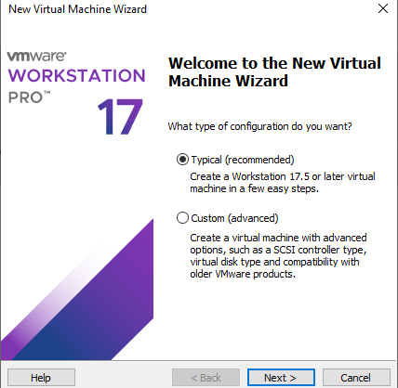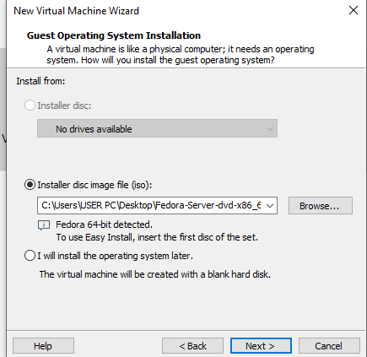
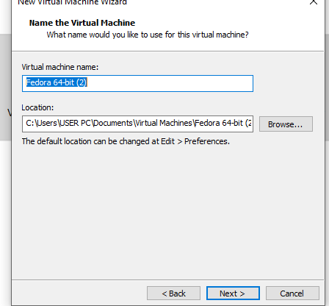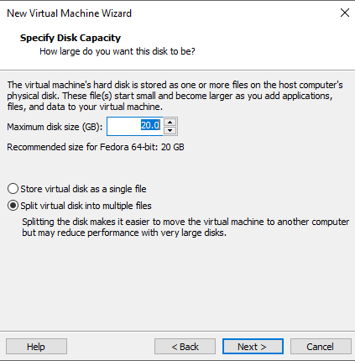
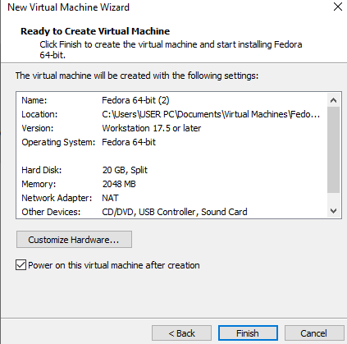
Click Finish and it will open the virtual machine and start setting up without interruption until it opens this page as shown in the images below;
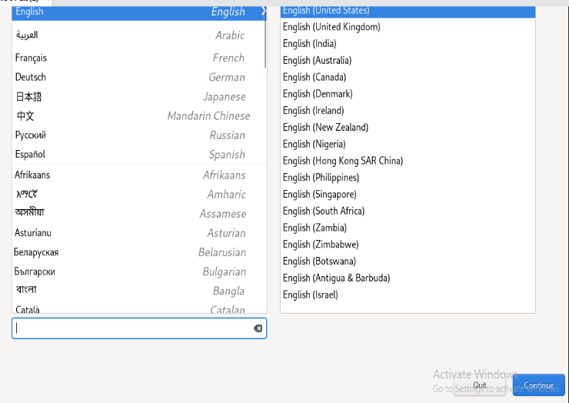
Press continue and the page in the image below will be shown, setup the places highlighted which are;
- Root account
- User creation
- Installation Destination
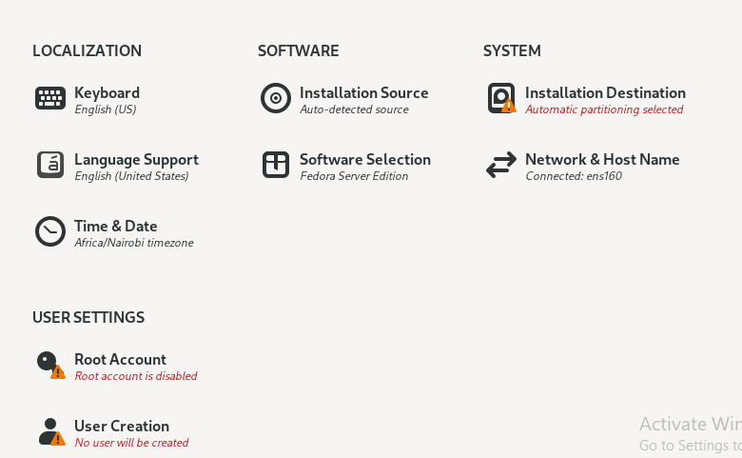
For root account click it and set as shown in the image below (use your desirable password) then press done
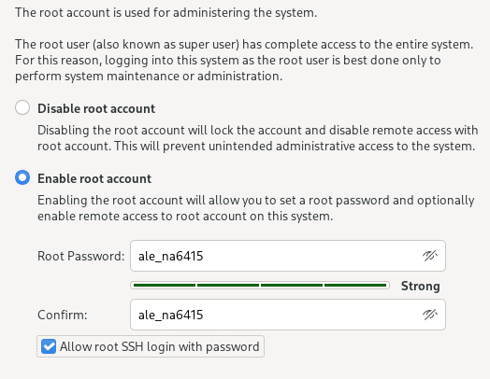
For User Creation click it and set as shown in the image below (use your desirable password) then press done
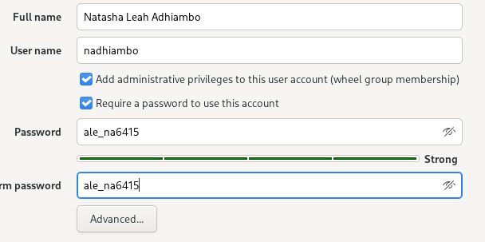
Once you are done it should show like this then click begin installation
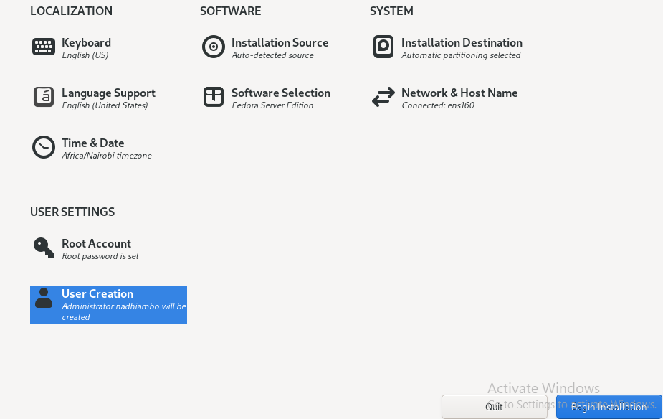
Once installation is done it will let you reboot the system, click reboot system once it boots it will take you to the command line interface as shown below
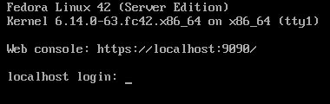
The machine is ready to start.
Enter your username and password correctly to login to your account
Update your Fedora server to the latest version using the command; sudo dnf update and let it run once done upgrade it using the command; sudo dnf upgrade –refresh –y and let it run.

